- pwa app with index and for now 1 point teaching plan, use some other points from demo.html, 15 points academic course file for now.
- It fetches data from g sheet named teaching plan. (sheet id fetched from master config g sheet file).
- This sheet have format: 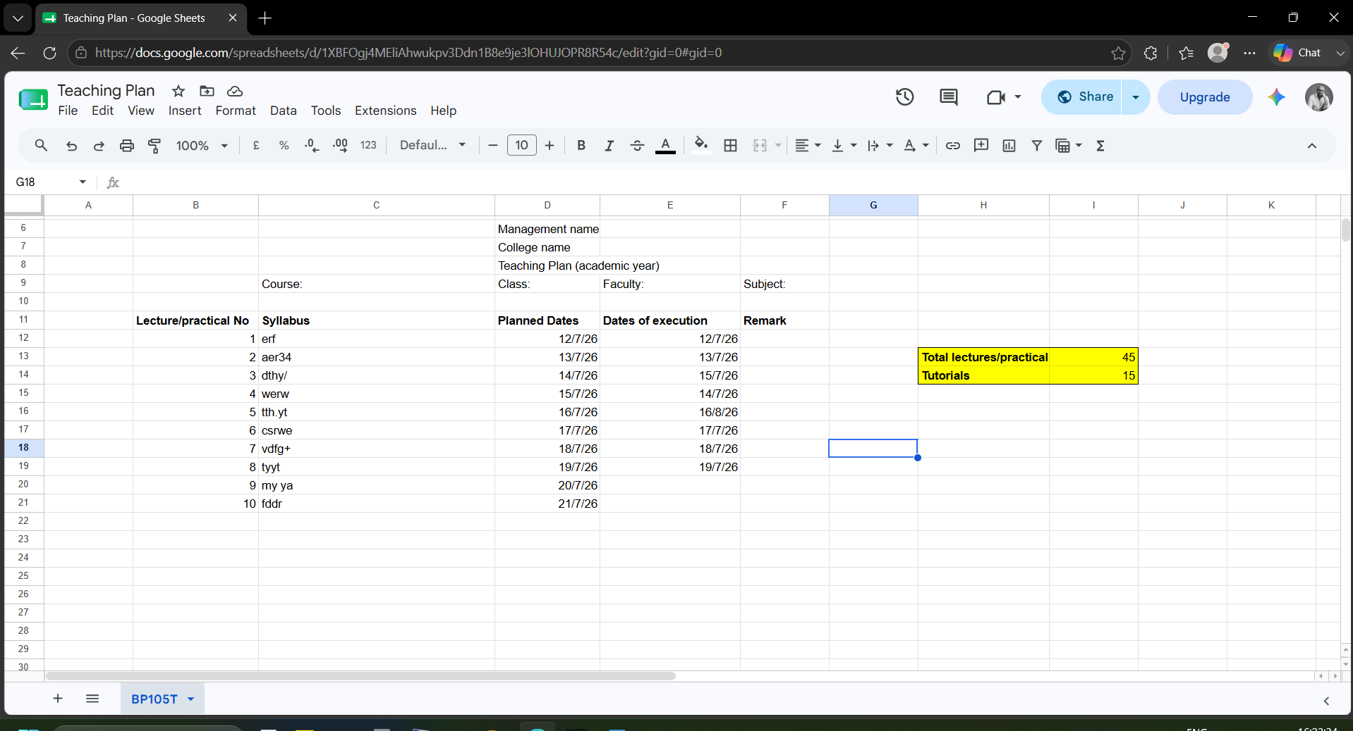
- Wire this app to g sheet (sheet id fetched from master config sheet).. that g sheet is attendance output from smart attendance app. This sheet contains: date of lectures/practicals and date on which it is actually conducted.
- As soon as app is launched, it will fetch data from attendance output and writes dates of execution in proper row matching syllabus point.
- In app display frontend, it will ask user for reason if dates planned and executed are mismatch.
- On dashboard it will also show syllabus completion meter.
- No of lectures/practicals, tutorials required to finish syllabus.
- Custom dates and all-time syllabus completion report. Monthwise. %
- Make some data fetched from attendance input g sheet (sheet id from master config excel) subject name, faculty, class course, academic year, sem
- Theme: read pwa-dashboard-theme-prompt file.
- Adacemic calenser pdf college and university, faculty workload auto calculate pdf, timetable , roll call pdf

